### **Chapter 5: Special Populations and Situations**

#### **Vulnerable Road Users (VRUs)**

**Definition and Characteristics**Vulnerable Road Users (VRUs) include pedestrians, bicyclists, motorcyclists, individuals using non-motorized transportation, and those with disabilities. These individuals are particularly at risk due to their lack of physical protection in collisions. Challenges for VRUs include uneven pavement, curbs, and road debris. Florida Statutes, *Section 316.027*, define VRUs and impose penalties for causing injury or death to them.

#### **Types of VRUs and Laws Protecting Them**

1. **Pedestrians – Click To Learn More**
   * Yield the right of way to pedestrians at crosswalks and intersections, regardless of whether they are marked. Drivers must stop and allow pedestrians to cross safely.
   * *Florida Statutes Section 316.130* requires drivers to exercise due care to avoid colliding with pedestrians and yield when a pedestrian is in a crosswalk.

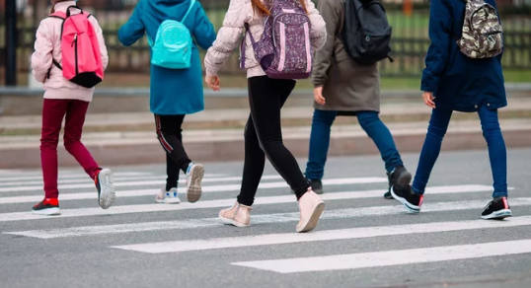

**Children – Click To Learn More**

Children are also considered vulnerable road users. In Florida, children under the age of 16 are required by law to wear a helmet when riding a bicycle. Additionally, drivers must exercise even greater care when driving near schools, parks, and residential areas where children are likely to be present.

**Elderly individuals – Click To Learn More**

Elderly individuals may have difficulty moving and reacting quickly, which makes them more at risk when they're on the road. You might see older people in places like their neighborhoods or retirement

**

1. **Bicyclists & Skaters – Click To Learn More**
   * Bicyclists are subject to the same rules and rights as vehicle operators. They must ride with traffic, use designated bike lanes, and obey signals.
   * Drivers must provide at least three feet of clearance when passing bicyclists, per *Florida Statutes Section 316.2065*.

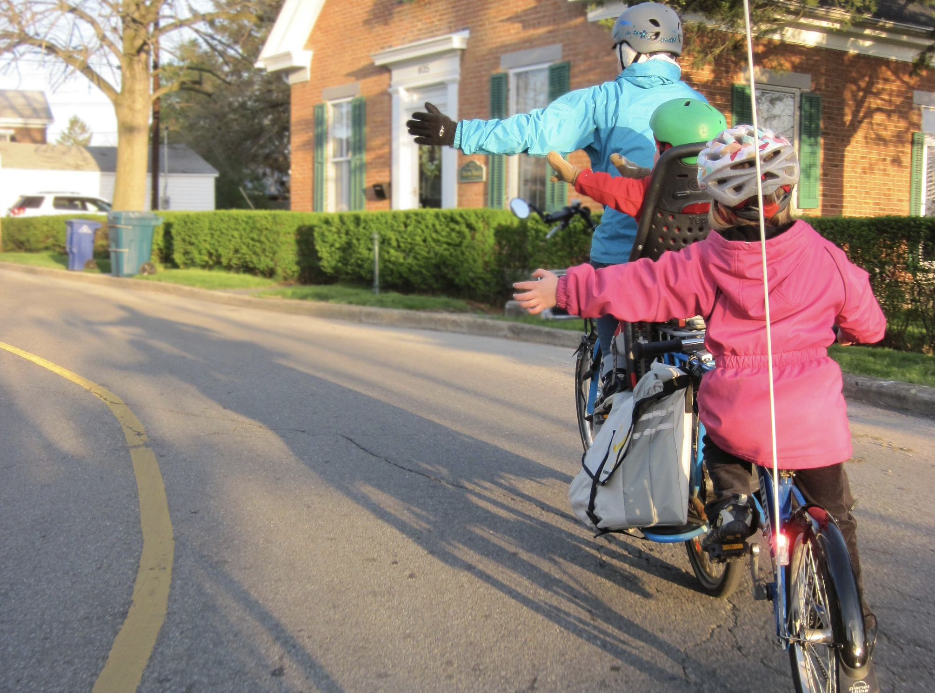

**Rollerbladers – Click To Learn More**

Rollerbladers are considered pedestrians when using sidewalks or crosswalks. Drivers must yield the right of way to them in these areas. It is important for rollerbladers and skateboarders to follow pedestrian rules, use designated areas when available, and be cautious of traffic.

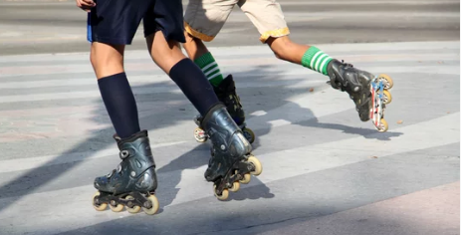

**Skateboarders – Click To Learn More**

In Florida, skateboarders are considered pedestrians when they are not actively engaged in skateboarding tricks or stunts. Drivers must yield the right of way to pedestrians, including skateboarders, at crosswalks and intersections (Florida Statute 316.130).

**Electric Scooters – Click To Learn More**

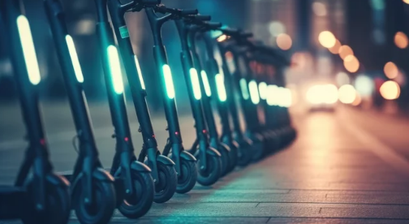

Electric scooters or Mo peds are subject to the same traffic laws as bicycles. Riders should follow traffic rules, ride in designated bike lanes when available, and yield to pedestrians. Drivers should exercise caution when sharing the road with scooter riders and provide them with adequate space.

1. **Motorcyclists – Click To Learn More**
   * Under **Florida Statute § 316.211**, **motorcyclists must wear eye protection** that meets Department of Highway Safety and Motor Vehicles (FLHSMV) standards. Helmets are also required **unless the rider is over 21 years old and carries at least $10,000 in medical insurance coverage for injuries resulting from a crash**. They must also keep headlights on at all times and operate with caution.
   * *Florida Statutes Section 316.211* mandates these safety measures for motorcyclists.



1. **Individuals with Disabilities – Click To Learn More**
   * Drivers must yield to individuals using white canes or guide dogs. Give wheelchair users extra time to cross and always be aware of people with disabilities. Stopping at a crosswalk occupied by a person with disabilities is mandatory.

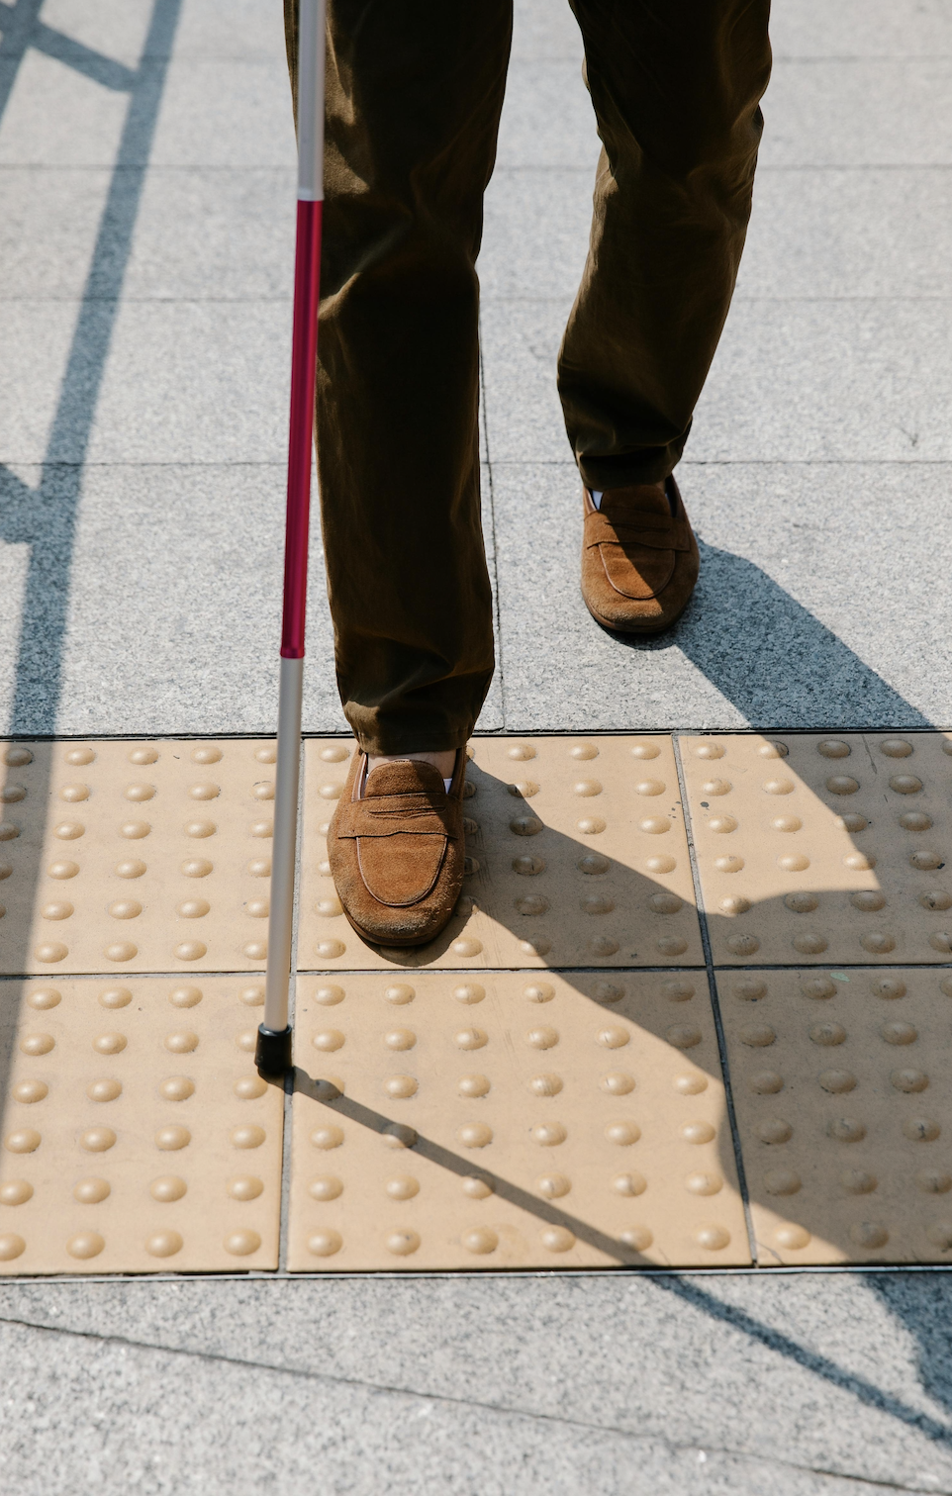

1. **Equestrians**



In Florida, drivers must exercise due care and reduce their speed when approaching or passing a person on horseback (Florida Statute 316.125). Drivers should also maintain a safe distance and give horses ample space when overtaking them.

Pedestrians are at risk in high-traffic areas and poorly lit crossings. Cyclists often share roads with vehicles, making designated bike lanes crucial. Children are unpredictable and lack traffic awareness, requiring extra caution near schools and parks. Elderly individuals may have slower reaction times and mobility challenges, increasing their risk at intersections. People with disabilities face additional risks, particularly at crossings without proper accommodations like curb cuts or audible signals.

## **VRU Characteristics and Environments**

### **Key Characteristics of Pedestrians**

Understanding pedestrian behavior is critical for all drivers. Pedestrians move without the protection of a vehicle, making them highly vulnerable in traffic environments. The following are key characteristics that influence their safety:

#### **Walking Speed and Reaction Time**

Pedestrians typically walk at an average speed of 3–4 mph, significantly slower than vehicle traffic. Drivers must anticipate this and adjust their speed accordingly when approaching crosswalks, intersections, or pedestrian-heavy areas. Allowing extra time and maintaining a safe buffer zone is vital to avoid conflicts.

#### **High Vulnerability in Crashes**

Because pedestrians lack any external protection, they are at far greater risk of serious injury or death in the event of a collision. According to the **National Highway Traffic Safety Administration (NHTSA, 2023)**, over **7,500 pedestrians** were killed in U.S. traffic crashes in 2022—the highest number in over four decades. This statistic highlights the urgent need for greater vigilance and responsibility from drivers.

### **Common Pedestrian Environments**

#### **Crosswalks and Intersections**

Marked and unmarked crosswalks are legally designated pedestrian zones. Florida Statute **316.130(7-9)** requires drivers to yield to pedestrians in crosswalks. Many pedestrian crashes happen at intersections, often due to driver inattention or failure to yield. Drivers must always check both sides before proceeding through or turning at intersections.

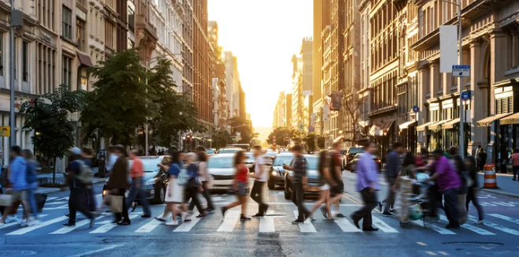

#### **Sidewalks and Footpaths**

Sidewalks are dedicated spaces for pedestrians and are legally off-limits to motor vehicles. Blocking or encroaching on sidewalks, even partially, compromises pedestrian safety and accessibility. When crossing sidewalks—especially when pulling into driveways or parking lots—drivers must yield to any pedestrian present.

#### **Residential Areas**

Neighborhoods often see a mix of vulnerable populations, including children, older adults, and individuals with disabilities. Because of reduced visibility (e.g., due to parked cars, hedges), drivers should be especially cautious and reduce their speed well below the posted limit when appropriate.

### **Driver Tips for Pedestrian Safety**

* Always stop for pedestrians in crosswalks—marked or unmarked.
* Be extra alert in school zones, near bus stops, and around parks.
* Never block crosswalks when stopped at a red light or stop sign.
* Avoid distractions—many pedestrian collisions occur within seconds of a driver losing focus.

### **Key Characteristics of Bicyclists**

Bicyclists are classified as vehicle operators in Florida, meaning they have the same rights—and responsibilities—as drivers of motor vehicles. But their size, speed, and lack of protection require drivers to adapt their behavior.

#### **Agility and Movement**

Cyclists can quickly change lanes, adjust position, or swerve to avoid hazards. Their movement may seem unpredictable to drivers who aren't accustomed to sharing the road. Maintaining a safe distance—at least 3 feet—is required under **Florida Statute 316.083(1)** when passing a cyclist.

#### **Balance and Stability**

Because bicycles are single-track vehicles, they are more susceptible to imbalance, especially in windy conditions or near large vehicles. Sudden braking, honking, or passing too closely can cause a cyclist to lose control. Drivers should always provide extra space and avoid actions that might startle the rider.

### **Bicyclist Environments**

#### **Bike Lanes and Shared Roadways**

Bike lanes are marked spaces that provide cyclists a designated travel path. It is illegal for drivers to park or drive in bike lanes except when turning or entering/exiting a driveway. On roads without bike lanes, bicyclists may “take the lane” to avoid hazards or improve visibility.

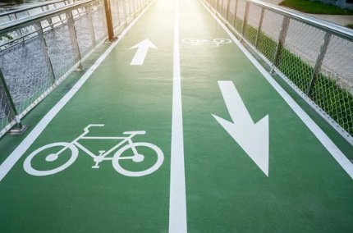

##### **Florida Examples:**

* **Biscayne Boulevard, Miami** – Protected bike lanes with barriers separate cyclists from traffic.
* **Orlando Residential Areas** – Bicyclists share narrow roads; drivers must slow down and allow ample space when passing.
* **Downtown Tampa** – Designated lanes help cyclists safely navigate intersections.
* **Key West** – Shared lane markings (“sharrows”) remind drivers to expect cyclists and share space.

#### **Urban Areas**

Cyclists are increasingly common in dense city centers due to the rise in bike commuting, bike-share programs, and sustainable transportation policies. Drivers should anticipate cyclists in downtown districts, at intersections, and near public transit hubs. Always check for cyclists, in your mirror and to your left through your window, before opening doors (“dooring”) and be cautious during right turns. Failing to do so could injure a cyclist or cause a collision.

##### **Tips for Driving in Urban Cycling Zones:**

* Yield to cyclists at intersections and driveways.
* Be patient—don’t pressure cyclists to move faster.
* Check for bike-specific signals or crossings.

#### **College Campuses**

Universities in Florida, such as UF, FSU, UCF, and FIU, have large cycling populations. Cyclists often ride across campus roads and may cross between buildings at unexpected points. Drivers should lower their speed and expect frequent cyclist activity, especially during class change times.

### **Driver Tips for Bicyclist Safety – Click To Learn More**

* Always give at least 3 feet of clearance when passing.
* Watch for bicyclists at intersections—especially during turns.
* Do not use bike lanes for driving or parking.
* Be aware of cyclists entering or exiting driveways, especially near campus zones or in residential neighborhoods.

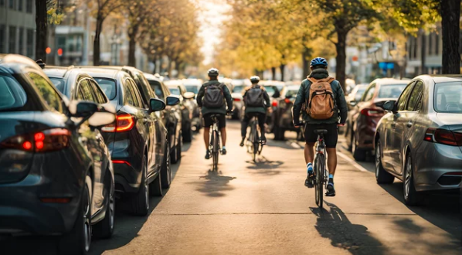

### **Characteristics of Motorcyclists**

Motorcyclists operate motor vehicles that offer speed and agility, but little protection. Understanding their unique capabilities and vulnerabilities helps drivers interact more safely.

#### **Speed and Acceleration**

Motorcycles can accelerate quickly and reach high speeds due to their lightweight design. Drivers must be aware that a motorcycle may appear farther away than it actually is and may approach faster than expected—especially when overtaking or merging.

* Always double-check before changing lanes or turning left across traffic.
* Avoid sudden movements that could cut off or startle a motorcyclist.
* Give motorcyclists extra time and space when they pass or merge.

In **2024**, motorcyclists made up **16% of all traffic fatalities in the U.S.**, despite accounting for only **0.6% of vehicle miles traveled**. The fatality rate for motorcyclists was approximately **31.39 deaths per 100 million miles traveled**, compared to **1.10** for passenger car occupants—making motorcyclists nearly **28 times more likely** to die in a crash per mile traveled (TRIP, 2025; NHTSA, 2024).

#### **Maneuverability**

Motorcycles are highly maneuverable and can swerve or shift lanes quickly to avoid obstacles. Drivers should:

* Avoid tailgating and provide extra following distance.
* Expect motorcyclists to reposition themselves in the lane for visibility or safety, but not rely on them to do so.
* Use turn signals early to give them time to react.



### **Motorcyclist Environments**

#### **Roadways and Highways**

Motorcycles travel on all types of roads, including high-speed interstates. Due to their smaller size, they can be easily hidden in a vehicle’s blind spots.

**Driver Tips:**

* Check blind spots twice before changing lanes.
* Never follow a motorcycle too closely—they can stop more quickly than cars.
* Watch for hand signals, as some motorcyclists may use them in addition to electronic signals.

#### **Recreational Areas**

Many motorcyclists ride in scenic areas for recreation. These routes often involve curves, elevation changes, and group rides.

**Driver Tips:**

* Be patient—do not pressure motorcyclists to speed up.
* Give space on curves and hills where visibility is limited.
* Expect group riders; pass them only when it is safe and legal.

### **Equestrians – Characteristics and Environments**

Horseback riders and horse-drawn carriages are legitimate road users, primarily found in rural and recreational areas. Their presence requires special attention.

#### **Key Characteristics**

* **Size and Speed:** Horses are large animals and usually move at slower speeds than vehicles.
* **Easily Startled:** Horses can react suddenly to loud noises, horns, or rapid movement.
* **Limited Maneuverability:** Horses and riders need more time and space to turn or stop.

#### **Common Environments**

* **Rural Roads:** Expect equestrians in agricultural or residential rural settings.
* **Designated Equestrian Zones:** Found in state parks, trails, and horse-friendly neighborhoods.

#### **Legal Requirement**

Under **Florida Statute 316.1905**, drivers must slow down and give horses a wide berth. Avoid honking or revving your engine near them.

### **Wheelchair Users – Characteristics and Environments**

Wheelchair users rely on mobility devices and often travel in pedestrian zones. Their safety depends on accessible infrastructure and careful driver behavior.

#### **Key Characteristics**

* **Mobility Limitations:** Power chairs and scooters may move at walking speeds or slower.
* **Low Visibility:** Their height and position make them harder to spot from a vehicle.
* **Accessibility Needs:** Require smooth surfaces, curb cuts, and access ramps.

#### **Common Environments**

* **Sidewalks and Curb Ramps:** These are essential for navigation—never block them.
* **Crosswalks:** Wheelchair users rely on the same pedestrian rights under **Florida Statute 316.130**.
* **Accessible Parking Zones:** Never park in or obstruct these areas unless you have the proper permit.

**Guidelines for Bikers & Motorcyclists**

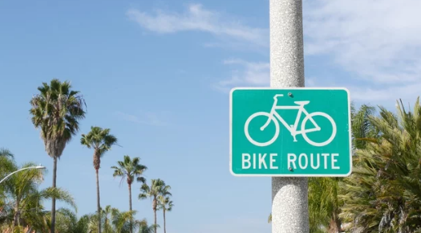

The Florida Bicycle Regulations outline the rights and responsibilities of bicyclists on the road.

**Some key provisions of this statute include**:

* **Riding on the right**: Bicyclists should ride as close to the right-hand curb or edge of the roadway as practicable, except when passing, making a left turn, or avoiding hazards.
* **Obeying traffic laws**: Bicyclists must follow the same traffic laws as motor vehicle operators, including stopping at red lights and stop signs.
* **Proper signaling**: Bicyclists are required to use hand signals to indicate turns or stops.
* **Bicycle lighting**: Bicycles operated between sunset and sunrise must be equipped with a front white light visible from 500 feet and a rear red reflector visible from 600 feet.

Florida Statute 316.2065 also outlines the required equipment for bicycles. Bicycles must be equipped with lights and reflectors for nighttime visibility, as well as brakes for safe operation. Drivers should be aware of the presence of lights and reflectors on bicycles, especially during low-light conditions, to anticipate their movements on the road.

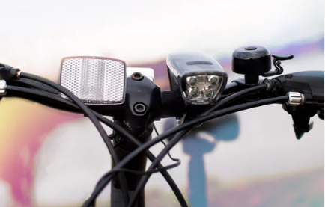

**Florida Statute 316.208: Regulations for Motorcyclists**

Motorcyclists have specific regulations outlined in Florida Statute 316.208.

**Some important provisions include:**

* **Licensing requirements**: Motorcyclists must possess a valid motorcycle endorsement on their driver's license or a motorcycle-only license.
* **Wearing helmets**: All motorcyclists are required to wear helmets while operating a motorcycle, regardless of age.
* **Equipment standards**: Motorcycles must be equipped with proper headlights, taillights, turn signals, and rearview mirrors.

### **Enhanced Infrastructure and Intersection Design: Prioritizing VRU Safety**

Improving infrastructure is a foundational step toward protecting vulnerable road users (VRUs)—including pedestrians, cyclists, wheelchair users, and others using non-motorized transportation. By advocating for safer, more inclusive road designs, we help build a transportation network that supports all users, not just drivers. This section outlines key strategies for enhancing infrastructure, particularly at intersections, where risks are often highest.

### **Dedicated Facilities for VRUs**

Creating clearly defined spaces for VRUs is critical to reducing conflict and preventing collisions. These dedicated facilities can include:

* **Bike lanes** that are protected or buffered from motor vehicle traffic
* **Accessible sidewalks** with ample width, curb ramps, and smooth surfaces
* **Multi-use trails** for pedestrians, joggers, cyclists, and other non-motorized users
* **Refuge islands and pedestrian buffers** that provide safe waiting areas in wider road crossings

By designing and maintaining these spaces, we not only improve safety but also promote walking and biking as realistic, everyday modes of transportation. Infrastructure that prioritizes VRUs encourages healthy, sustainable mobility while reducing traffic congestion and emissions.

To ensure effectiveness, it’s important to base these developments on current standards and evidence-based practices—such as those outlined by the **Florida Department of Transportation (FDOT)**, which offers detailed design manuals and planning guidelines for pedestrian and bicycle infrastructure.

### **Intersection Design: Critical Safety Zones**

Intersections are high-risk areas where VRUs often encounter fast-moving vehicles, limited visibility, and complex traffic patterns. Designing safer intersections is essential to protecting lives. Key features of VRU-friendly intersections include:

* **Dedicated signal phases** for pedestrians and cyclists to reduce conflict with turning vehicles
* **High-visibility crosswalks** with bright paint, textured pavement, or pedestrian-activated signals
* **Tighter curb radii** to slow vehicle turning speeds and shorten crossing distances
* **Raised crossings or pedestrian refuge islands** to make crossing safer and more manageable
* **Bike boxes and advanced stop lines** that allow cyclists to position themselves visibly ahead of vehicles at red lights

**Traffic Calming Measures**: Implementing traffic calming measures, such as speed bumps, raised crosswalks, or roundabouts, can help reduce vehicle speeds and enhance the safety of VRUs. For example:

* Speed bumps or speed humps encourage drivers to slow down in residential areas, where pedestrians and bicyclists are more likely to be present.
* Roundabouts can improve safety by reducing the number of potential conflict points and slowing down vehicle speeds at intersections.

#### **Enhancing VRU Safety in High-Risk Areas**

* **Residential Areas and School Zones:** Always adhere to reduced speed limits and anticipate the presence of children or others crossing the road unexpectedly.
* **Intersections:** Exercise caution and yield to pedestrians and cyclists as required by Florida Statutes, such as FS 316.130 for pedestrians’ right-of-way.
* **Bike Lanes:** Avoid encroaching on bicycle lanes and check for cyclists before turning or merging.

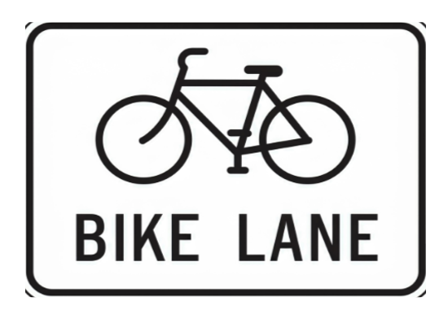

**Infrastructural Devices**

A well-designed and maintained physical environment significantly enhances the safety of **vulnerable road users (VRUs)**, including pedestrians, cyclists, and other non-motorized road users.

#### **Key Safety Features**

**Sidewalks**

Properly maintained sidewalks provide a **dedicated space** for pedestrians, reducing the risk of pedestrian-vehicle collisions.

**Crosswalks**

Clearly marked and maintained crosswalks help ensure that pedestrians can cross streets safely.

**Florida Statute 316.130** requires drivers to stop and yield the right of way to pedestrians in crosswalks.

**Bike Lanes**

Designated bike lanes offer cyclists a **protected area** to travel and reduce conflicts with motor vehicles.

In areas without designated bike lanes, cyclists and motorists share the road. These are known as shared roadways. Drivers should be aware of the presence of cyclists and provide them with sufficient space, practicing safe passing maneuvers and maintaining a safe distance.

**Speed Reducing Measures**: Speed humps, raised crosswalks, and narrow roads slow vehicles, particularly in residential and school zones.

**Merging Zones**: Designated areas allow cyclists to integrate into traffic before junctions, improving safety.

## **Florida Statute 316.0083 – Bicycle and Pedestrian Traffic Control Signals**

Florida law recognizes the need to enhance safety for all road users, especially **vulnerable road users (VRUs)** like pedestrians and bicyclists. One important tool used to protect these individuals is the **installation of special traffic control signals** designed specifically for their movement through intersections and road crossings.

Florida Statute **316.0083** authorizes the use of **bicycle and pedestrian-specific signals**, helping to reduce conflict with motor vehicle traffic and provide safer, more predictable crossings.

### **Understanding Bicycle and Pedestrian Signals**

#### **1. Special Signal Indications**

Signals intended for bicycles and pedestrians may use **distinct icons**, such as a **walking figure** or a **bicycle symbol**, to indicate when VRUs may cross safely. These signals are **separate from standard vehicular traffic lights** and should be understood and respected by drivers.

**Tip:** Just as you recognize green, yellow, and red lights for cars, drivers should learn to recognize pedestrian walk symbols and bicycle signal phases to anticipate when VRUs may be entering a crossing.

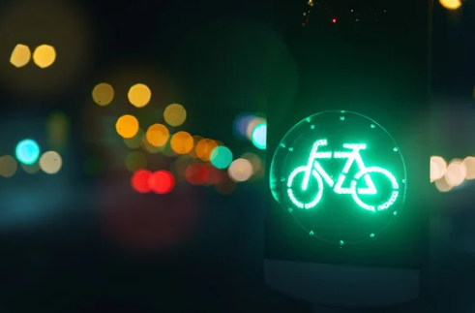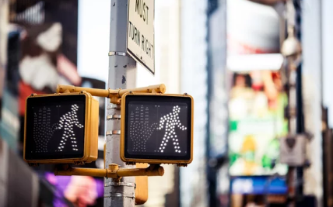

#### **2. Right-of-Way Requirements**

When a pedestrian or bicycle signal is active, **those users have the legal right-of-way** in the designated crossing area. Motorists must **yield** and remain stopped until the signal indicates it is safe to proceed. Failure to yield in these scenarios can result in penalties and increases the risk of injury or death.

#### **3. Shared Roadway Considerations**

In some intersections, bicyclists and pedestrians may share the roadway or use standard traffic signals. Regardless of the type of signal in place, drivers must:

* Be **vigilant when turning** across crosswalks or bike lanes.
* Yield to VRUs who are **lawfully crossing** the roadway.
* Be alert for VRUs even when **standard traffic lights** are active.

#### **4. Legal Compliance by All Road Users**

Both drivers and VRUs are **required to obey traffic signals**. Just as drivers must stop at red lights, bicyclists and pedestrians are expected to follow their designated signals. However, because VRUs are less protected, it is **especially critical for drivers to exercise caution**, even if a VRU appears to be violating the signal.

*Remember:* Even when a VRU is at fault, the driver’s vehicle poses the greater risk of injury or fatality. Defensive driving saves lives.

#### **Innovative Measures in Florida**

Florida has adopted several innovative infrastructure measures to enhance VRU safety, including:

**Bike Boxes:** Special areas at intersections allowing cyclists to position themselves ahead of motor vehicles during red lights, increasing visibility and reducing the risk of right-turn collisions.

#### **Purpose and Function**

A **bike box** is a marked area at the front of a traffic lane—typically at signalized intersections—designed to give bicyclists a safe and visible space to wait ahead of motor vehicles. These designated zones help cyclists position themselves for through movements or turns before traffic begins to move.

#### **Enhancing Cyclist Visibility**

Bike boxes significantly improve the visibility of bicyclists to drivers. By allowing cyclists to queue in front of vehicles, especially at busy intersections, bike boxes reduce the likelihood of collisions—particularly those involving right-turning vehicles. Increased visibility helps drivers recognize cyclists early and adjust their actions accordingly.

#### **Navigating Signal Changes**

When the traffic light turns green, drivers must **yield to any cyclists occupying the bike box**, allowing them to move through the intersection safely. This includes waiting to make right turns until cyclists have cleared the area. Respecting this right-of-way reduces the potential for dangerous conflicts between vehicles and bicycles during signal transitions.

#### **Legal Compliance and Safe Behavior**

Florida traffic law requires motorists to **avoid stopping in or blocking bike boxes**. Drivers must understand that bike boxes serve to protect vulnerable road users and facilitate safer turning and merging interactions. Yielding to cyclists and maintaining clear bike box space at red lights is both a legal requirement and a key part of responsible driving behavior.

**Advanced Bicycle Stop Lines:** Markings that create a buffer zone between stopped vehicles and bicycles at traffic lights, providing cyclists with a safer start when lights change.

**Advanced Stop Lines (ASLs)**: Separate stop lines give cyclists a head start at traffic lights, reducing collision risks.

#### **Purpose and Placement**

Advanced stop lines—are marked areas placed in front of vehicle stop lines at signalized intersections. These areas allow **bicyclists to position themselves ahead of motor vehicles** while waiting for a green signal. This placement enhances their visibility to drivers and traffic signals, reduces the risk of collisions—especially from right-turning vehicles—and gives cyclists a safe and timely head start through the intersection.

#### **Driver Compliance and Mutual Respect**

When approaching an intersection with an advanced stop line, drivers must stop **behind the designated line**, even if no cyclists are present. Encroaching into this space is illegal and compromises cyclist safety. Respecting this space allows cyclists to enter the intersection first, improves line-of-sight for all road users, and minimizes conflict points between bikes and vehicles.

#### **Safety and Traffic Efficiency**

Complying with advanced stop lines contributes to safer and more predictable traffic movement. By allowing cyclists a clear and visible starting position, motorists reduce the likelihood of **“right hook” crashes**—collisions caused by drivers turning right across the path of a cyclist proceeding straight. These safety zones help separate turning and through-movements and foster a more organized and efficient traffic flow.

#### **Driver Scenario Example**

You're driving through a Florida city and approach a signalized intersection with an **advanced stop line** marked in front of a green-painted **bike box**. A cyclist in the bike lane signals and moves into the box ahead of you as the light remains red. You **stop behind the white line**, giving them clear space to wait. When the light turns green, the cyclist moves through the intersection first, and you proceed once they’ve cleared the area. By following the rules and respecting the advanced stop line, you help protect the cyclist, reduce the chance of a collision, and support a more predictable traffic environment.

Take a minute here to explain the *wrong* way to handle VRUs like bicyclists and pedestrians on roadways. What have you learned about your responsibility towards them as a driver?

**Key Takeaway:**Advanced stop lines and bike boxes are critical for cyclist safety and driver accountability. Stopping behind these lines is not just courteous—it’s required. Giving cyclists the space they need promotes safer, more efficient intersections for everyone.

**Signal Timing**: Lead intervals for pedestrians and advanced green signals for cyclists prioritize VRUs at intersections.

### **Letting Cyclists Merge Before a Junction**

When approaching a junction, it's important to be mindful of cyclists who may be merging into your lane or preparing to turn. **Cyclists** are considered **vulnerable road users**, and they have the same rights as drivers to navigate intersections safely.

#### **Why It’s Important to Let Cyclists Merge**

* **Safety**: Cyclists are smaller and more vulnerable than motor vehicles, making them less visible in traffic. Allowing them to merge or make their way into the junction ensures they can do so safely without feeling rushed or at risk of being cut off.
* **Legal Responsibility**: In Florida, drivers are required to treat cyclists with respect, yielding the right of way when necessary (Fla. Stat. § 316.2065). Allowing a cyclist to merge before a junction is not only courteous but also a legal requirement to ensure safe coexistence on the road.

#### **How to Safely Allow Cyclists to Merge:**

* **Maintain a Safe Distance**: Always give cyclists **plenty of space**. Avoid crowding them or driving too close, especially when approaching a turn or junction.
* **Slow Down**: If you see a cyclist preparing to merge or enter a junction, it’s a good idea to **slow down** to give them enough time and space to maneuver safely.
* **Signal Your Intentions**: Use your **turn signals** early to indicate to the cyclist that you're planning to turn or change lanes, so they can adjust their position accordingly.
* **Be Patient**: Give cyclists time to settle into their lane and ensure they have sufficient space before making your turn.

#### **Encouraging Safer Conditions**

These measures aim to:

1. Minimize interactions between motor vehicles and VRUs.
2. Provide predictable pathways for all road users.
3. Improve the overall safety and efficiency of shared roadways.

### **School Bus Safety: Florida's Rules and Penalties**

When approaching a school bus with **flashing yellow lights**, drivers must prepare to stop. This signals that the bus will begin loading or unloading children within approximately 10 seconds. Once the **lights switch to flashing red**, drivers must:

1. **Come to a complete stop** and remain stopped until:
   * All children have safely cleared the roadway.
   * The bus driver turns off the flashing red lights to indicate "all clear."
2. **Exercise caution** when proceeding, as children may still be nearby and might not be attentive to traffic.

#### **Legal Requirements and Penalties (FS 316.172)**

* **Passing a stopped school bus** is a serious criminal offense in Florida. Violations include:
  + Hefty fines (potentially hundreds of dollars).
  + License suspension.
  + Mandatory hearings with state officials for repeat offenses.
  + Possible jail time for subsequent violations.
* Drivers must stop for school buses on **undivided roadways**, even if the bus is on the opposite side of the road.

#### **Automated Enforcement of Violations (FS 316.173, 2023 SB 766)**

To enhance compliance, Florida law permits school districts to use **infraction detection systems** on buses. These systems capture violations, enabling enforcement of penalties for drivers who fail to stop for school buses with extended stop signals.

This updated measure emphasizes child safety and enforces stricter accountability for protecting young pedestrians. Always prioritize vigilance and care near school buses and in school zones to ensure the safety of all children.



## **Florida Laws Protecting VRUs**

Understanding and following Florida traffic laws is critical to ensuring the safety of pedestrians, bicyclists, and all vulnerable road users (VRUs). Below are the most relevant state statutes and how they apply in real-world driving scenarios.

### **Pedestrian Rights and Driver Responsibilities**

Florida Statute **316.130** outlines the rules governing pedestrian behavior and motorist obligations. These regulations are central to preventing pedestrian injuries and fatalities.

#### **Right-of-Way in Crosswalks**

Pedestrians have the legal right-of-way when crossing within **marked or unmarked crosswalks at intersections**. Drivers are required to **stop and yield** to pedestrians entering or already within a crosswalk (Florida Statutes, 2024).

*Example:* When approaching an all-way intersection with a pedestrian stepping into the crosswalk, you must stop and allow them to fully cross your lane before proceeding.

#### **Yielding and Vigilance**

Drivers must yield to pedestrians who are in or approaching crosswalks. This includes both marked and unmarked crossings at intersections. It is also essential for drivers to slow down in areas with heavy foot traffic, school zones, or bus stops.

#### **Duty of Due Care**

Drivers are legally obligated to exercise **"due care"** to avoid striking pedestrians. This includes reducing speed in pedestrian-heavy areas, avoiding distractions, and watching for children or individuals using wheelchairs or mobility devices (Florida Statutes, 2024).

### **Additional Protections for Vulnerable Road Users**

Statute **316.1303** expands on protections for all VRUs, including pedestrians, bicyclists, and others using non-motorized forms of transportation.

#### **Enhanced Penalties**

Drivers who commit **moving violations** that result in **serious bodily injury or death** to a VRU are subject to **increased penalties**, such as fines, license suspension, and mandatory driver improvement courses. These penalties are designed to reinforce the importance of exercising caution around VRUs (Florida Statutes, 2024).

#### **The Three-Foot Rule**

When passing a bicyclist or other VRU, drivers must allow at least **three feet of clearance** (Florida Statutes, 2024). If it’s unsafe to pass with that space, drivers must wait until it is safe to do so. This simple guideline greatly reduces the risk of sideswipe collisions.

### **Florida Statute 316.2065 – Bicycle Operation and Motorist Duties**

Statute **316.2065** governs how bicycles must be operated on public roads—and how motorists are expected to safely interact with them.

#### **Equal Rights and Duties**

Bicyclists have the same rights and responsibilities as motor vehicle drivers. They are permitted to use any road (except where prohibited) and are entitled to occupy a full lane when necessary for safety. Motorists must treat bicyclists as legitimate traffic participants (Florida Statutes, 2024).

##### **Examples of When to Yield to Bicyclists:**

* **At intersections**: If a bicyclist arrives first or is crossing your path, yield to them as you would any other vehicle.
* **In bike lanes**: Do not block or drive through bike lanes. Always yield before turning across a bike lane.
* **From driveways**: Always look for bicyclists approaching from either direction before pulling out.

#### **Passing and Overtaking Safely**

When overtaking a bicyclist:

* Move into the adjacent lane if possible.
* Provide a **minimum of three feet** of space between your vehicle and the bicycle.
* If traffic or road conditions make this difficult, slow down and pass only when safe.

##### **Passing Scenarios:**

* **Single-lane road**: Wait for oncoming traffic to clear, then move left and pass with at least 3 feet of clearance.
* **Multi-lane road**: Use a full adjacent lane to overtake.
* **Narrow roads with oncoming traffic**: Reduce your speed and wait for a clear opportunity to pass safely.

### **Additional Resources**

* **Florida Department of Transportation (FDOT)** – [www.fdot.gov](https://www.fdot.gov) Access state-approved road safety resources, driver guides, and updates on VRU safety initiatives.
* **Official Florida Statutes** – www.leg.state.fl.us  
   Use this resource to find the full text of Florida Statutes **316.130**, **316.1303**, and **316.2065**.

#### **Driver Responsibilities for VRUs**

1. **Interacting with Bicyclists**
   * Treat bicyclists as vehicles and respect them on the road.
   * Provide at least three feet of space when passing a bicyclist.
   * Check for bicyclists before opening car doors or turning.
2. **Pedestrian Safety**
   * Always yield to pedestrians at crosswalks and intersections. Avoid distracted driving and reduce speed in areas with high pedestrian traffic.
   * Drivers are prohibited from passing vehicles stopped at crosswalks as they may be yielding to pedestrians (*Section 316.130*).
3. **Children and School Zones**
   * Drivers must stop for school buses with flashing red lights and exercise caution in school zones.
   * *Florida Statutes Section 316.172* mandates stopping for buses on undivided roadways.

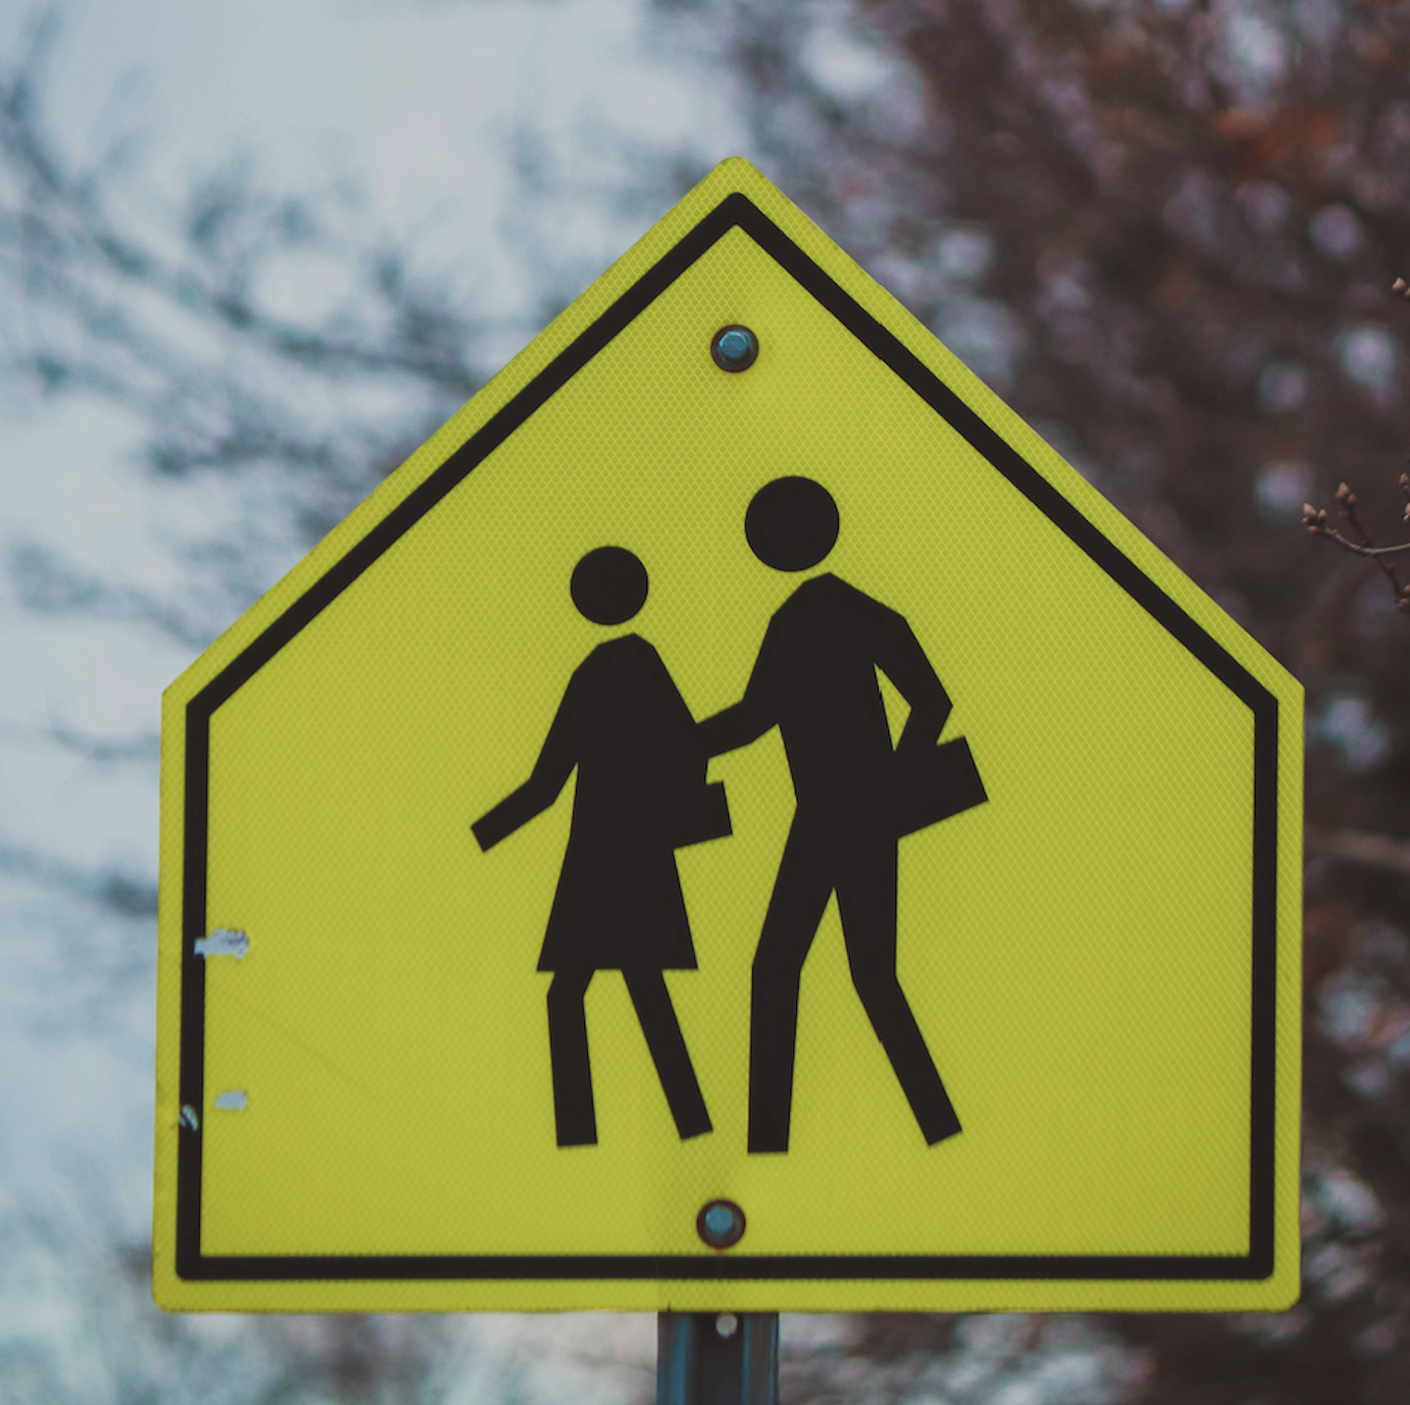

1. **Individuals with Disabilities**
   * Drivers must stop completely for visually impaired individuals using white canes or guide dogs until they have safely crossed.

Florida law provides specific protections for **vulnerable road users (VRUs) with disabilities** to ensure their safety in traffic environments.

#### **Key Provisions from Florida Statutes Section 316.1303**

1. **Yielding to Blind or Visually Impaired Pedestrians**
   * Drivers must yield to pedestrians who are blind or visually impaired and using a **white cane** or **guide dog**.
   * Drivers are required to come to a **complete stop** and must not enter a crosswalk while such a pedestrian is crossing.
2. **Traffic Violation and Penalties**
   * Failure to yield can result in **traffic violations** and **monetary fines**.

#### **Practical Example**

If a visually impaired individual is crossing the road with a white cane or guide dog, drivers must:

* Stop completely.
* Wait until the pedestrian has entirely crossed the roadway before proceeding.

#### **Awareness and Vigilance**

Drivers should:

* Stay alert in areas with high pedestrian traffic, such as **schools**, **hospitals**, and **residential zones**.
* Be extra cautious near crosswalks and intersections to identify and respond to VRUs with disabilities.

**Florida Statutes Section 318.14** addresses penalties for infractions involving **vulnerable road users (VRUs)**. Under this provision:

1. **Civil Penalty**: Individuals responsible for infractions that result in serious bodily injury or death to a VRU must pay a **specified civil penalty**.
2. **Driver's License Suspension**: Offenders face a suspension of their **driver's license for a designated period**.
3. **Mandatory Driver Improvement Course**: The offender is required to complete an **approved driver improvement course** to enhance their understanding of traffic safety and prevent future incidents.

These measures emphasize the importance of protecting VRUs and holding drivers accountable for actions that jeopardize road safety. For more details, visit the [Florida Department of Highway Safety and Motor Vehicles](https://www.flhsmv.gov).

### **Sharing the Road**

Sharing the road involves being a considerate and attentive driver, ensuring the safety of all road users, including pedestrians, bicyclists, motorcyclists, trucks, and even animals. By following proper road-sharing techniques, drivers can significantly reduce the likelihood of collisions and create a safer driving environment for everyone.



#### **General Guidelines for Sharing the Road in Florida – Click To Learn More**

1. **Yield Right-of-Way:** Always prioritize safety and follow right-of-way rules, especially at intersections and crosswalks.
2. **Stay Alert:** Avoid distractions and remain focused on the road to anticipate the actions of other road users.
3. **Use Turn Signals:** Signal your intentions to help other road users understand your movements and maintain safe distances.
4. **Maintain a Safe Distance:** Give adequate space to all vehicles, especially VRUs like bicyclists and motorcyclists.

For detailed guidance, refer to the official [Florida Highway Safety and Motor Vehicles Handbook](https://www.flhsmv.gov/resources/handbooks-manuals/).

**Communication and Respect for Vulnerable Road Users (VRUs):**

Drivers play a crucial role in protecting vulnerable road users—such as pedestrians, cyclists, wheelchair users, and others relying on non-motorized transport. Creating a safer environment for everyone begins with clear communication and mutual respect.

**Signaling Your Intentions:**

Effectively signaling your next move is key when sharing the road. Always use your vehicle’s turn signals to show when you’re planning to turn, change lanes, or merge. Consistently signaling in advance gives VRUs time to anticipate your actions and respond safely. In situations involving pedestrians or cyclists, using hand signals along with your vehicle's indicators can further improve communication and prevent misunderstandings.

**Practicing Patience and Courtesy:**

Patience and thoughtfulness go a long way in keeping VRUs safe. Since they typically travel at slower speeds and have less protection than motor vehicles, it’s important to allow them extra time and space. Avoid aggressive actions like tailgating, honking unnecessarily, or sudden lane changes that might startle or endanger them. A calm and respectful attitude helps create a more predictable and secure road environment for all.

By practicing these habits, drivers can significantly reduce the likelihood of collisions and help protect the most vulnerable members of our traffic system.

#### **Sharing the Road with Motorcyclists**

Motorcycles are smaller and less visible than cars, making them more vulnerable to collisions. To ensure safety, follow these guidelines:

1. **Check Blind Spots and Mirrors**
   * Motorcycles can easily be obscured in blind spots. Always double-check your blind spots and mirrors before making a lane change or turn.
2. **Give Them Space**
   * Never share a lane with a motorcycle. They require a full lane to maneuver safely.
   * Provide at least a four-second following distance to give motorcycles ample time to respond to road hazards.
3. **Signal Your Intentions**
   * Use turn signals early to communicate your movements and help motorcyclists plan their actions.
4. **Be Cautious at Intersections**
   * Intersections are particularly hazardous for motorcyclists. Look carefully for motorcycles, especially when making left turns.
5. **Avoid Sudden Stops**
   * Sudden stops can lead to rear-end collisions, especially for motorcyclists. Brake smoothly to give them time to react.

By adhering to these practices, drivers can contribute to safer roadways and reduce the risks faced by motorcyclists.

### **Driver Responsibility**

Drivers bear a crucial responsibility to protect vulnerable road users (VRUs), such as pedestrians, cyclists, wheelchair users, and others relying on non-motorized transportation. By adopting safe driving practices and remaining vigilant, drivers can significantly reduce the risks posed to these road users, who often lack physical protection.

#### **Safe Driving Techniques for Protecting VRUs**

1. **Be Alert**
   * Always maintain full attention on the road and surrounding areas.
   * Watch for VRUs, particularly in areas with heavy foot traffic, such as school zones, parks, and urban streets.
2. **Slow Down**
   * Reducing speed is critical when approaching VRUs, giving you more time to react.
   * In areas frequented by pedestrians or cyclists, adjust your speed to ensure safety.
3. **Give Space**
   * When passing VRUs, maintain a safe distance. Florida law (FS 316.083) requires drivers to provide at least three feet of clearance when overtaking a bicyclist.
   * Use another lane when available to ensure adequate space.
4. **Use Turn Signals**
   * Clearly signal your intentions to turn or change lanes.
   * Signaling allows VRUs to anticipate your actions, reducing potential conflicts.
5. **Be Patient**
   * VRUs may move at slower speeds than motorized traffic.
   * Wait for them to cross safely or proceed before continuing your journey.